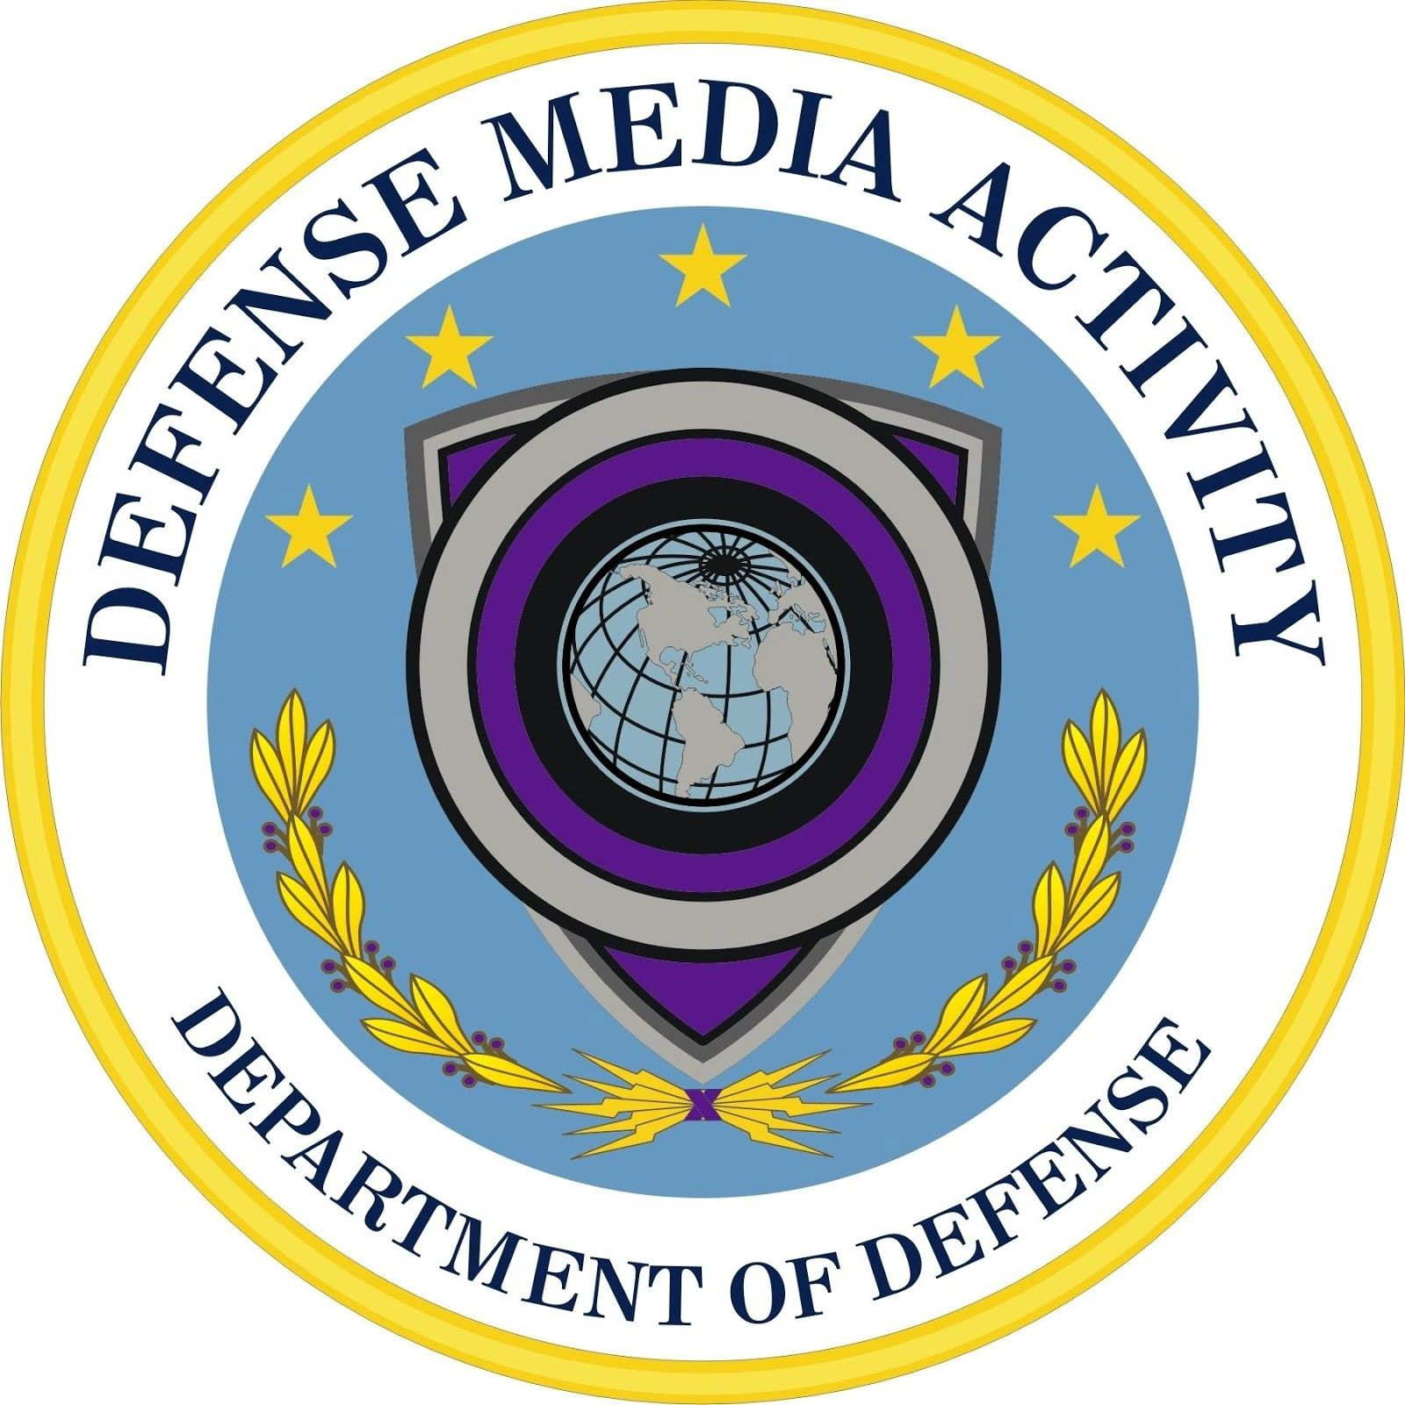

Defense Media Activity Strategy 2025
Transforming for the Competitive Environment

May 2019

www.dma.mil

Contents
Contents 2
Director’s Message 3
Introduction 5
Strategy 7
Mission 7
Vision 7
Our Value Statement 7
Our Strategy 8
Strategic Goal 1: Rebuild readiness and improve workforce talent 8
Strategic Goal 2: Modernize DoD Public Affairs Training and Education 9
Strategic Goal 3: Enhance our support to Joint Forces and DoD Components 9
Strategic Goal 4: Improve business performance and affordability 10
Connecting to the Department 10
Putting Strategy into Action 12
Annual Performance Plan 12
Priorities 12
Challenges 12
Organization Overview 13
How We Fit in the Department 13
Our Objective Organization 14
Our Services 15
Our Customers 16
Summary 16
History 17
Our Seal 18

Director’s Message
The Defense Media Activity is the mass media and education organization that creates and distributes Department of Defense content across a variety of platforms to audiences worldwide. DMA is different than the other 27 Defense Agencies and Field Activities as it’s the only one responsible for developing, creating, and effectively engaging targeted audiences with DoD information.
Comprised of 1,500 employees at 45 locations worldwide to meet the Department’s information requirements, every member of the DMA Team plays a meaningful role for the Nation and is part of a proud lineage.

The Information domain is constantly evolving and we cannot allow ourselves to be held to the methods and standards of the past. Today’s communication environment is dynamic and without mercy to those not savvy to its capabilities. We must aggressively pursue effective means of communication on behalf of the Department and relinquish operations of legacy and costly applications. To ensure DMA adds value in its mission space, it must fine tune its efforts and proactively evolve capabilities to meet mission requirements. DMA Strategy 2025 focuses on transforming capabilities to better support the Department and operate in a manner that dominates throughout the ever-changing information environment.

THE WAY AHEAD: DMA will modernize its core mission requirements – Education and Production. Components will undergo an in-depth review of operations and recommend to eliminate, restructure, or consolidate processes to increase effectiveness and reduce costs. The alignment process will have clear objectives and a clear mission set. The mission and objectives will drive the entire realignment process and will:

- Redefine relationships between current Lines of Business to ensure they function as an integrated entity with multiple functional disciplines
- Develop talent, issues management, engagement strategy, and enterprise content skills within the Activity. DMA will work seamlessly as an Department-level Asset
- Recruit, develop, and retain a talented and motivated workforce while sustaining an integrated team capable of delivering effective content and mission results

- Evaluate opportunities to eliminate, restructure, or consolidate processes and day-to-day operations to increase effectiveness and reduce costs

- Conduct a rigorous self-assessment utilizing analytic capabilities to produce fact-based evidence to evaluate mission impact; secondary order of effects (multiple geographic locations); and develop sustainable, automated management capabilities to track targeted outcomes
- Restructure functions and/or programs to better meet the needs of its stakeholders and to strengthen the ability of the Department to disseminate accurate, timely and targeted information concerning DoD activities and missions on behalf of DMA clients
- Modernize DoD public affairs training and education core competencies to improve capabilities in the field
- Improve functional area efficiency by coordinating, planning, and executing the intersection of content, relationships, and engagement to create, publish, and distribute DoD content to targeted audiences
- Improve return on investment for talent development, issues management, engagement strategy, and enterprise content production activities individually and as a whole
- Incorporate data/metrics collection and analysis to better inform decision makers and to best measure success of key public affairs and visual information goals and establish accountability for outcomes
- Ultimately deliver targeted content driven by real-time knowledge of the information environment and the audience

This strategy establishes my intent to pursue an urgent evolution to DMA’s core mission requirements. We must use creative approaches and be disciplined in our execution. By doing this, DMA will continue to tell the story of America Service Members sworn to defend our Nation well into the future.

Mission First, People Always

Introduction
DMA Strategy 2025 focuses on transforming our capabilities to better support the Department and operate in the ever-changing information environment. We developed the strategy based on the results of the DMA 2019 Strategic Assessment1 held November 2018 to April 2019, which was phase 1 of the DMA transformation process.
We completed a top-to-bottom analysis of our guiding missions, functions and
services-based guidance in the 2018 National Defense Strategy of the United States of America2 (NDS), National Defense Business Operations Plan3 (NDBOP), and Joint Concept for Operating in the Information Environment4 (JCOIE). We ensured our assessment addressed specific guidance from the Assistant to the Secretary of Defense for Public Affairs (ATSD(PA)) on the transformation of the DoD Public Affairs enterprise.

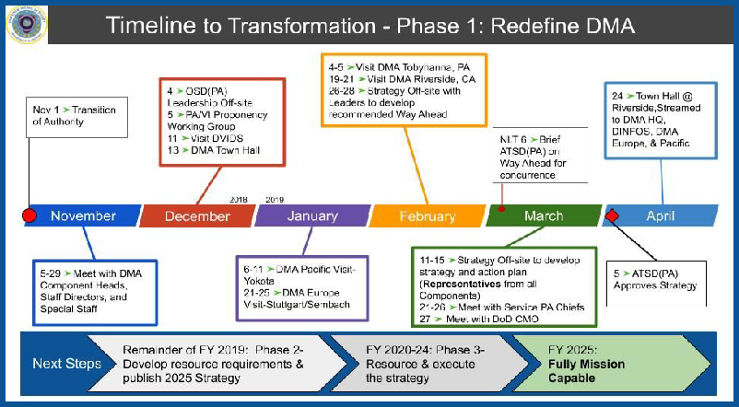
Phase 1 encompassed significant meetings, briefings and planning sessions. We engaged our primary customers, OSD leadership, and DMA employees to ensure we addressed their concerns and
requirements. We connected with industry and academia to better understand the future of media communications. Finally, DMA leadership collaborated on a routine basis to ensure a shared understanding of the information and data collected.

We learned many things during the assessment and after detailed analysis. For example:

- Our mission and functions must change to meet the challenges of the NDS and
Information function.

1 The DMA 2019 Strategic Assessment is available upon request
2 The NDS is available at
https://www.defense.gov/Portals/1/Documents/pubs/2018-National-Defense-Strategy-Summary.pdf
3 The NDBOP is available at https://cmo.defense.gov/Publications/NDBOP.aspx
4 The Joint Concept for Operating in the Information Environment (JCOIE) 2018, available at https://www.jcs.mil/Doctrine/Joint-Concepts/Joint-Concepts/

- We must address global operations of our regional capabilities to better support Combatant Commands and other regional Commanders.
- Our shared services must be better organized and measured to improve performance and readiness for more effective and efficient mission execution.

These discoveries and many other lessons learned will be addressed as we execute DMA Strategy 2025. Our new mission, vision and value statements set the foundation, while our strategic goals target the end state. This document provides the high-level strategy to guide our ongoing actions to transform DMA for the competitive environment.

Strategy

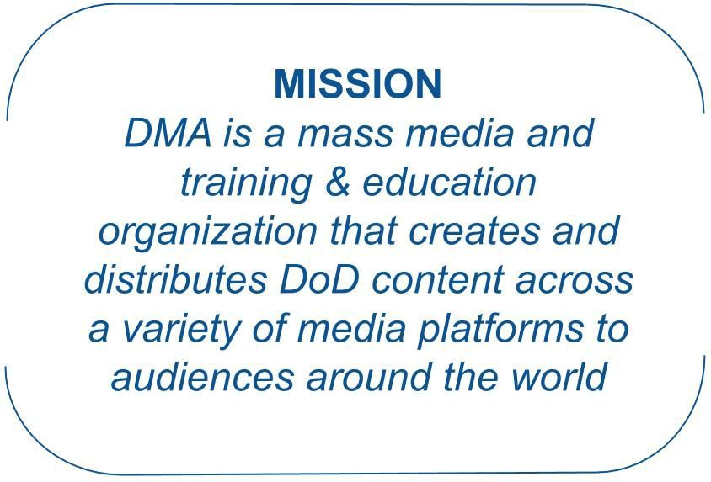
Mission
The NDS, NDBOP, and Joint Concept for Operations in the Information Environment validate the necessity for dominance in the information domain. We must ensure the joint force commanders and DoD senior leaders we support can communicate effectively. Professional media services, tailored to their missions and messages, will enhance their lethality, alliances, and business processes. We will train and
educate their communicators, augment their organic capacity with cutting-edge capabilities, integrate into their operations, and advise them expertly.

Vision
What we do is essential for the Department of Defense. The modern information environment demands agile and superior communication. How our military interacts with the American people and the public worldwide directly influences the whole of the
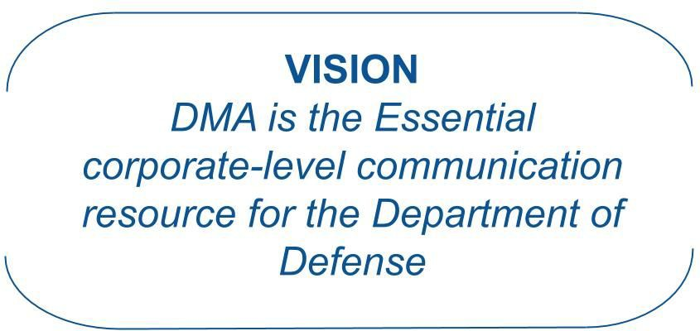
United States government. We have the talent, discipline, and experience to succeed, and to be leaders across all Federal agencies in the professions of public affairs, visual information, and communicative arts. We should always be the standard for everyone else to achieve.

Our Value Statement
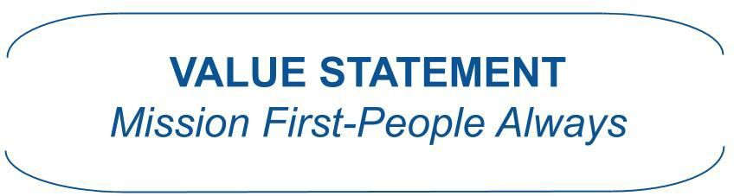
We embrace and uphold DoD Core values of leadership, professionalism, and technical know-how with special emphasis that we all must live by duty, integrity, ethics, honor, courage, and loyalty. With these and the

core values of each Service and DoD Civilians, DMA’s focus is on the two things above all: Mission success and taking care of our people.

Our Strategy
DMA will support the ATSD(PA) plan to transform the DoD public affairs enterprise, while meeting the Secretary’ directed responsibilities to provide common services as a DoD Field Activity. We will also integrate the Secretary’s intent to improve our competitive edge through a more lethal force, stronger alliances, and greater performance and affordability through reform. DMA will improve its ability to redefine, unify and integrate communications and content activities by applying the following key tenets:

- Communications operates as an integrated enterprise-level asset
- Communication roles recast as functional disciplines matching organizational needs
- Enterprise content recognized as an organizational operating model
- Leverage the combination of Speed, Information and Relationships
- Build Key Performance Measures to achieve the best Return on Investment

Finally, we will take care of our people fostering a culture focused on performance, talent and diversity. To achieve all of this, our Strategic Goals for success are:

Strategic Goal 1: Rebuild readiness and improve workforce talent
Strategic Goal 2: Modernize DoD public affairs training and education Strategic Goal 3: Enhance our support to Joint Forces and DoD Components Strategic Goal 4: Improve business performance and affordability

Strategic Goal 1: Rebuild readiness and improve workforce talent
More than 50 percent of the DMA workforce are military service members. As partners of the Military Services, we must maintain and sustain their readiness for war. They must be able to “integrate new capabilities, adapt warfighting approaches, and change

business practices to achieve mission success.”5
We must also recruit, develop, and

retain a world-class civilian workforce and build an integrated civilian and military team focused on mission results with right balance of contracted support. We will provide the best workforce development opportunities maintaining our role as leaders in media
5 National Defense Business Operations Plan (NDBOP), Strategic Goal 1: Rebuild Military Readiness as We Build a More Lethal Joint Force, page 8.

communications. DMA must prepare to receive the military communicators of the future graduating from Defense Information School (DINFOS) March 2020. We must transform our workforce structure to prepare for this new, multi-functional, multi-capable communicator.

Strategic Results: Our integrated civilian and military team is focused on outcomes for our clients. Our military workforce meets the warfighting readiness requirements of their respective Services and the demands of the Joint Force. We have the right talent and workforce balance (civilian, military, contractor) to execute our missions.

Strategic Goal 2: Modernize DoD Public Affairs Training and Education
Public Affairs uses many legacy processes and technologies that have diminishing relevance in the modern Information Environment (IE). Public Affairs training and education must be revised to produce more effective communicators. Stronger partnerships with the Military Services, industry, and academia will ensure we deliver the best training for public affairs professionals. We must also facilitate senior-level education to be more effective for the Military Services and Joint Force Commanders.

Strategic Results: The Department has military communicators that operate confidently in the modern information environment. Military communicators support their Commanders with relevant and agile capabilities.

Strategic Goal 3: Enhance our support to Joint Forces and DoD Components
We will close critical gaps in service delivery, mission support, organizational structures, control and direction, resource management, performance reporting, and other areas.
We must reassess how we support the Combatant Commands, Military Departments, other DoD agencies and activities, and the Office of the Secretary of Defense. We will realign our overseas activities to better support the European and Pacific regions. Our structural changes must provide more career opportunities for both our military and civilian workforce. We will help the Department achieve readiness and build a more lethal Joint force through exceptional communication support.

Strategic Result: DMA’s resources, capabilities, and processes are effectively aligned and employed to provide our clients with leading military communication capabilities in their most complex operating environments.

Strategic Goal 4: Improve business performance and affordability
As a DoD Component, we fully support the Department’s ongoing business reform efforts and will shift to focus more on performance and affordability as outlined in the NDBOP and DAFA Review. We will enhance our shared service capabilities, streamline end-to-end business operations, act on well-informed performance data, and create results-driven objectives.

Strategic Results: We provide efficient, cost effective media services to support DoD communication objectives that enable more lethal and ready Joint Forces. We have streamlined end-to-end business operations, well-informed performance data, and results-driven objectives.

Connecting to the Department
The 2018 National Defense Strategy of the United States of America (NDS) outlines the Department’s long-term strategy. The Secretary highlights the true focus of the NDS in the subtitle: Sharpening the American’s Military Competitive Edge. This focus is clearly explained by the challenge facing the Department.

Today, we are emerging from a period of strategic atrophy, aware that our competitive military advantage has been eroding. We are facing increased global disorder, characterized by decline in the long-standing rules-based international order—creating a security environment more complex and volatile than any we have experienced in recent memory. Inter-state strategic competition, not terrorism, is now the primary concern in U.S. national security.

To overcome this challenge, the NDS outlines a strategic approach that “requires the seamless integration of multiple elements of national power—diplomacy, information, economics, finance, intelligence, law enforcement, and military power.” To achieve this integration, the Secretary directed three priorities which are specifically outlined in the National Defense Business Operating Plan (NDBOP) as Strategic Goals (SG):

- SG1: Rebuild military readiness as we build a more lethal Joint Force;
- SG2: Strengthen alliances as we attract new partners; and
- SG3: Reform the Department’s business practices for greater performance and affordability

We make specific connections in our strategy to each of the three strategic goals. Per SG3, the DoD Business Reform efforts began in 2017 when the Secretary first directed the Department to conduct a thorough business review. All DoD Components were directed to identify viable reform initiatives to make the Department more effective and efficient, and achieve the business reforms necessary to restore military lethality and readiness in the following lines of business:

- Human Resource (HR) Management*
- Financial Management*
- Real Property Management*
- Acquisition and Contract Management*
- Logistics and Supply Chain Management*
- Healthcare Management
- Community Services*
- Cyber Defense and Information Technology Management*
- Testing and Evaluation

Since early 2017, DMA has worked with DoD Reform leaders per the lines of business that apply to our mission.6 Many of these reforms are in progress and some are yet to be started. DMA continues to support these efforts and highlight those in our strategy and annual plans.

In addition to DoD Reforms, the Assistant to the Secretary of Defense for Public Affairs (ATSD(PA)) identified three areas of transformation in support of the NDS and NDBOP:

- Communication: Review business processes and identify Lines of Effort that directly support core Public Affairs mission to communicate with internal and external stakeholders.
- Public Affairs Professional Education and Training: Review and identify existing Public Affairs education and training structures, methods, policies and procedures; and assess and make recommendations to eliminate, consolidate or restructure entities or functions to enhance the educational opportunities and outcomes for Service Members and civilians within the career field.
- Public Affairs Technology Requirements: Review and evaluate technology needs for the Public Affairs Function (globally) and as part of efforts to consolidate and restructure essential mission execution Lines of Effort.

6 The asterisk (*) in the list of DoD lines of business identifies which reforms impact DMA.

We analyzed these areas and integrated appropriate initiatives to support the PA transformation.

Putting Strategy into Action

Annual Performance Plan
The DMA Strategy 2025 is put into action via the DMA Annual Performance Plan (APP), which is published separately. The APP is an enterprise-level view of resources and actions for a given fiscal year. The APP is organized into Strategic Objectives and Strategic Initiatives. Strategic objectives reflect the outcome or management impact we want to achieve. The objectives specifically express the desired outcomes that represent progress in specific areas. Strategic initiatives are our actions to achieve objectives. They are designed to close a performance gap, add capability to improve performance, or introduce a new capability where performance is needed. The DMA APP includes an Action Plan as a separate appendix for the current and four more fiscal years.

Priorities
The APP outlines priorities based our strategic assessment. These are synchronized with the Department and ATSD(PA) priorities, and those we consider to be essential to improve customer experience. The priorities are reviewed on a quarterly basis and updated annually or sooner if a significant change is required based emerging urgent requirements.

Challenges
With any strategy, we have challenges that influence planning and execution. Below are those challenges we consider the most important. Some are drivers for change, while others are for situational awareness in our decision-making process. These challenges provide an understanding of our operating environment:

- The Chairman of the Joints Chiefs of Staff (CJCS) issued an out of cycle change to doctrine to add Information as a new Joint function. This change specifically impacts our mission. Our strategy will support this effort. We must be agile and adapt to change driven by the Joint Staff that impacts the Joint Force and Military Services. Our initiatives impacted the Information function will be flexible.

- The DoD conducts other reforms as outlined in this document. They, too, impact our mission as they take shape. We must be agile and ready to adapt to these as the Department works to achieve the goals of the National Defense Strategy.
- The Military Departments have completely revamped the Public Affairs (PA) career field to consolidate all PA and Visual Information (VI) into single “military communicator” for the enlisted members. They are updating the requirements for the officers as well. The near-term impact is at our Defense Information School (DINFOS) with the development and implementation of Military Communicators Foundations (MCF) course and an update to the Public Affairs Qualification Course (PAQC). DMA must evaluate how to operate in the future joint environment with this new, single military communicator, scheduled to flow from DINFOS in 2022 and beyond.

Organization Overview

How We Fit in the Department
DMA is a DoD Field Activity established by the Secretary of Defense under authority granted in U.S. Law. Section 191 of Title X, United States Code states “whenever the Secretary of Defense determines such action would be more effective, economical, or efficient, the Secretary may provide for the performance of a supply or service activity that is common to more than one military department by a single agency of the Department of Defense.”

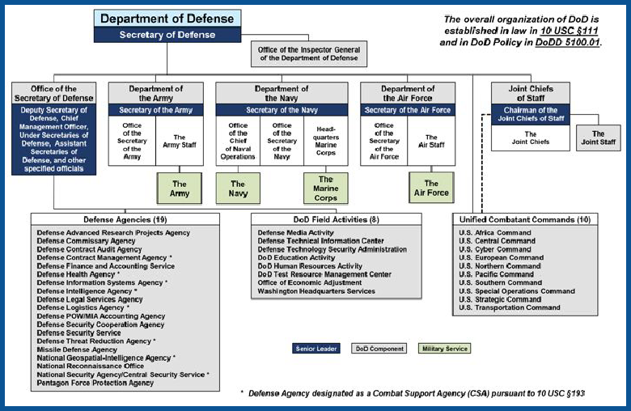
DMA is one of the 28 DoD Field Activities and Defense Agencies established under Title X, Section 191. The Office of the Secretary of Defense (OSD), the Joint Staff, Combatant Commands,
Military Departments and Agencies
and Field Activities are collective referred to as ‘DoD Components’ as depicted in DoD Organization Chart (right). Although not organizationally part of OSD, all Field Activities and Agencies like DMA are under the authority, direction, and control of an official in the

OSD, known as the Secretary’s Principal Staff Assistant (PSA). DMA is under the authority of the Assistant to the Secretary of Defense (Public Affairs) (ATSD(PA)).

Our Objective Organization
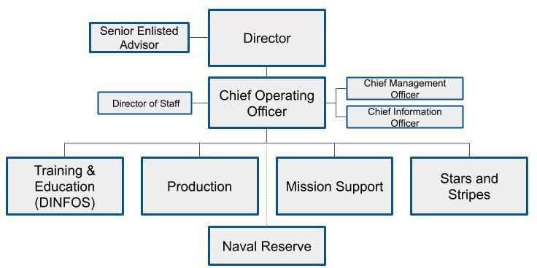
DMA is organized with a Headquarters and seven components. There is also a Naval Reserve Unit that works with DMA to fulfill its obligations to the U.S. Navy. A foundational element of our transformation is the realignment to an objective organization of four Lines of Business with a Headquarters comprised of the Director, Chief Operating Officer, Senior Enlisted Advisor, Chief Management Officer, Chief Information Officer, and a Director of Staff (below). This organizational grouping recognizes our core mission and support functions and will be implemented in stages over the coming years.
The functions of the headquarters and lines of business are:

- Headquarters: controls and directs the lines of business, manages resources, provides strategy and performance evaluation, policy, business and mission systems architecture, and a special staff for the Director.
- Training and Education: executed by the Defense Information School, provides professional communication Joint education & training for military and civilian personnel across a variety of media platforms to meet DoD-wide entry level skills and long-term career development requirements.
- Production: advises, plans, creates, distributes and assesses targeted DoD digital information products across a variety of media platforms to worldwide audiences to meet communication objectives.
- Mission Support: provides goods and services, control and account for resources, and provide advice for human resources, financial, logistics, technology, facilities, and other support functions.

- Stars and Stripes: provide first-hand reporting from bases worldwide and unbiased, credible news to America’s military.

Our Services
In addition DMA Core Mission functions of Production, Training & Education and Stars and Stripes, we provide shared services to the Department. These include:

- DoD Visual Information (VI) Records Management: Under Title 44, the Secretary of Defense is required to submit records to the National Archives and Records Administration (NARA) to help preserve the history of the United States. DoD is the custodian of the largest amount of visual information records7 in the Federal government. Military photographers, videographers, journalists, and graphics specialist produce more visual records than any other department. Due to the significant number of VI records generated by the DoD, the Secretary designated DMA as the proponent for Defense Visual Information. DMA operates and maintains the DoD VI Records Management program for all DoD Components.
- DoD Public Web Program: The Department uses websites to communicate information and effectively engage the American public. DMA manages the DoD Public Web Program for numerous Components. In 2019, this encompasses almost 800 websites. This program continuously evolves as the media landscape changes with the advent of Social Media, mobile apps and other technological advances.
- Defense Visual Information Distribution Services (DVIDS): DVIDS is a state-of-the-art, 24/7 operation that provides a timely, accurate and reliable connection between the media worldwide and the U.S. military serving at home
and abroad. Through a network of portable Ku-band satellite transmitters located in-theater, robust IP connections, and a distribution hub DVIDS makes available real-time digital broadcast-quality video, still images, print products and immediate interview opportunities with service members, commanders and subject matter experts.
- Television-Audio Support Activity (T-ASA): T-ASA performs e essential engineering –service requirements and support functions: analysis, design, build tasks for radio and television, visual information, media archival, storage and duplication, and combat camera systems for the DMA. T-ASA also provides this

7 VI records may include but are not limited to still and motion photography, audio recordings, multimedia, graphic art, broadcast recordings, posters, magazines and will include future visual media as they are developed.

service to other DoD components and Federal clients on a reimbursable basis. Significantly, T-ASA is the Coordinated Acquisition Authority’ (CAA) for the Federal Supply Classification (FSC) 5820, “Radio and Television Communication Equipment, Except Airborne.”

Our Customers
DMA executes mission functions for and provides services to all DoD Components. The primary Training and Education customers are Military Departments as we are chartered to execute their Title 10 training responsibility for public affairs and visual information enlisted and officer initial entry training. We train more than 3000 military students each year. We provide production support to the senior Public Affairs leaders for each military service, as well as the Secretary of Defense via the Office of the Assistant to the Secretary of Defense for Public Affairs (OSD(PA)). We also support each of the Combatant Commands in the United States and overseas, as well as garrison and installation commanders and Component Commands overseas via the American Forces Network (AFN).

Summary
DMA Strategy 2025 is significant in many ways. We changed our mission statement and vision to better communicate what we do for the Department. We created goals and objectives to improve workforce readiness and to make DMA an incredible communication capability for our customers. We will realign its organization to better support the National Defense Strategy and Information as the 7th Joint Function. DMA will improve performance through evidence-based, quantitative measures of success.
These are just a few of many ways our new strategy leaves behind the status quo and moves forward to more competitive methods to mission execution. Our stakeholders can and should hold DMA accountable to continuously improve our performance and agility to meet the demands of a rapidly changing information environment.

History
In the 2005 Defense Base Realignment and Closure Act (BRAC) report to the President, the Secretary of Defense recommended the creation of a new DoD Media Activity that consolidated a number of military department media organizations with similar missions into a new organization. These organizations were:

- Army’s Soldier Magazine, Fort Belvoir, Virginia.
- Naval Media Center, Anacostia Annex, District of Columbia
- Army Broadcasting-Soldier Radio/TV, Alexandria, Virginia
- Air Force News Agency-Army/Air Force Hometown News Service, San Antonio, Texas

The Secretary’s recommendation also included co-locating American Forces Information Services (AFIS) with the new DoD Media Activity and the existing Defense Information School at Fort George G. Meade, Maryland.

The Secretary’s recommendation met several important Department of Defense objectives with regard to future use of leased space, rationalizing the presence of DoD activities within the National Capitol Region (NCR), and enhanced security for DoD activities. The creation of a new DoD Media Activity, as a result of consolidating a number of entities with similar missions, promoted “jointness” and created opportunities for common support cost savings and operational synergy. The consolidation reduced the Department’s reliance on leased space by eliminating approximately 75,000 Usable Square Feet (USF) of leased administrative space. The location of the activity at Fort Meade, which is outside the boundaries of the NCR, provided a dispersion of DoD activities away from the dense concentration around Washington D.C. This, plus the immediate benefit of enhanced force protection afforded by Fort Meade, provided compliance with force protection standards. In November 2005 the BRAC recommendations assumed the force of law and the Department was required to execute them by September 15, 2011. DoD Leadership formally began work in late in 2006 to design DMA’s new home at Fort Meade.

In 2007, as DMA planning moved forward, executive leaders recognized three shortfalls in the BRAC recommendation. First, it would result in two co-located organizations: the consolidated Military Service organizations and AFIS. Second, similar Marine Corps functions were not included. Finally, there was not a specific timeline of actions other than the September 2011 deadline. Subsequently, on September 24, 2007, the Deputy

Secretary of Defense (DSD) issued the directive-type memorandum, "Establishment of the Defense Media Activity" to address these shortcomings. As a result, the Secretary of Defense formally established the Defense Media Activity (DMA) January 1, 2008 via DoD Directive 5105.74. On October 1, 2008, Military Departments retained the BRAC personnel savings and the remaining positions and budget were transferred to DMA.
On April 8, 2009, DMA held a ground-breaking ceremony in a field on Fort Meade. After more than two years of hard work, DMA opened its doors in April 2011 and welcomed the first members. By August 2011, final staff moves from the former organizations into the new facility were complete. It’s important to note DMA is far larger than the headquarters and media facility and the DINFOS schoolhouse at Fort Meade as more than half DMA is stationed worldwide.

Our Seal
The five stars represent each of the consolidated media groups. The shield symbolizes defense and safeguarding America’s freedom. Purple represents the joint military mission of the activity. The annulets represent the strata of airwaves expanding outward into the infinite. The globe symbolizes a world-wide reach to the combined activities. The annulet combined with the globe embodies the camera lens focused on the world. The cinnamon wreath represents success and champions all forms of communication. The bundle of lightning bolts is a reference to the speed with which communications travel through the five media groups combined as one.

www.dma.mil

